CITY OF BOSTON
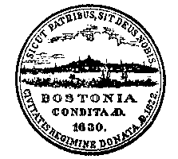

CODE OF ORDINANCES

Thomas M. Menino, Mayor

City Council – 2013

Councilor Stephen J. Murphy, President

Councilor Mark S. Ciommo Councilor Bill Linehan
Councilor John R. Connolly Councilor Michael P. Ross
Councilor Rob Consalvo Councilor Matt O'Malley
Councilor Frank Baker Councilor Tito Jackson
Councilor Felix G. Arroyo Councilor Charles C. Yancey
Councilor Salvatore LaMattina Councilor Ayanna Pressley

Maureen Feeney, City Clerk

William F. Sinnott, Corporation Counsel

Contains local legislation current through Ord. 2012, c. 9, passed 12-28-12
AMERICAN LEGAL PUBLISHING CORPORATION

432 Walnut Street Cincinnati, Ohio 45202-3909 (800) 445-5588

